Fifteen years of Orthopaedic Referrals in South Wales
Report by Rhiannon Lewis RVN

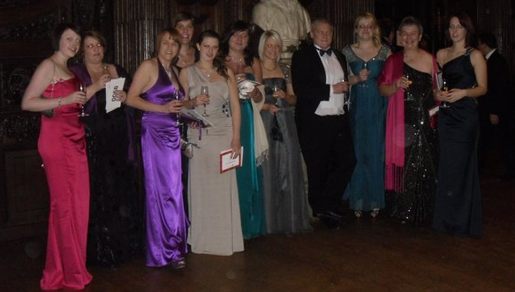
The Alphavet Referral team (from Risca, South Wales) swapped their surgical theatre gowns for ball gowns (and a tuxedo) for an evening of celebrations. The team were marking their fifteenth year of offering small animal orthopaedic and spinal referrals for the South East Wales region. They attended a Burn’s Night Supper at Middle Temple Hall, the Inns of Court, in London on 29th January. The evening began with a champagne reception followed by the ceremonial entrance of the haggis in the grand hall. An exquisite five course meal was enjoyed by all, where the traditional Scottish haggis was served accompanied by the obligatory scotch whiskey. Dinner was followed by the toast to the lassies and a toast to the laddies. The main event was the Scottish ceilidh dancing. Even the boss had his dancing shoes on.

